ASSIGNMENT 7

Que 1. Write a query that counts all orders for october 3.
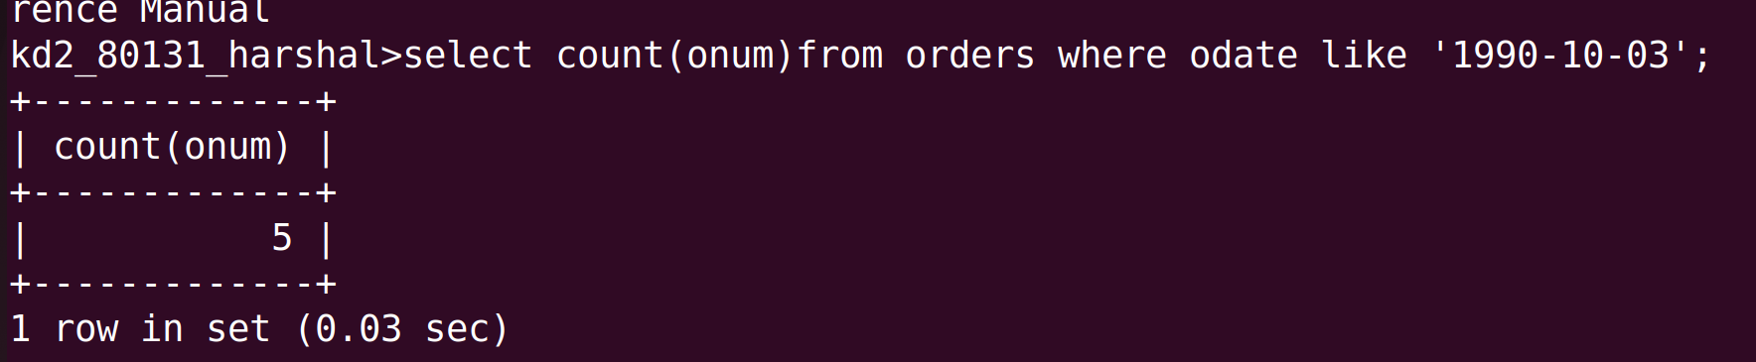
Que 2. Write a query that counts the number of different non-null city values in the customers table.
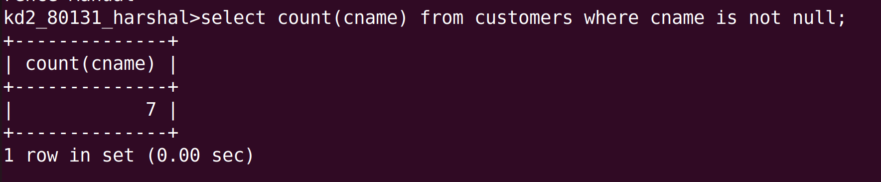
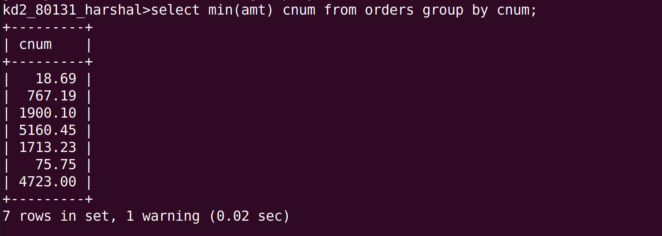
Que 3. Write a query that selects each customers smallest order.

Que 4.Write a query that selects the first customer, in alphabetical order, whose name begins with G.

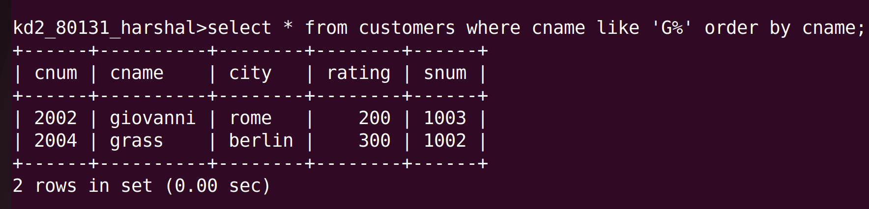
Que 5. Write a query that selects the highest rating in each city.

Que 6.Write a query that counts the number of salespeople registering orders for each day.(if a salespeople has more than one order on a given day, he or she should be counted only once).
